Chapter 5 programming practice 2023

# FIFO page replacement algorithm

Given the common.h

## Common.h

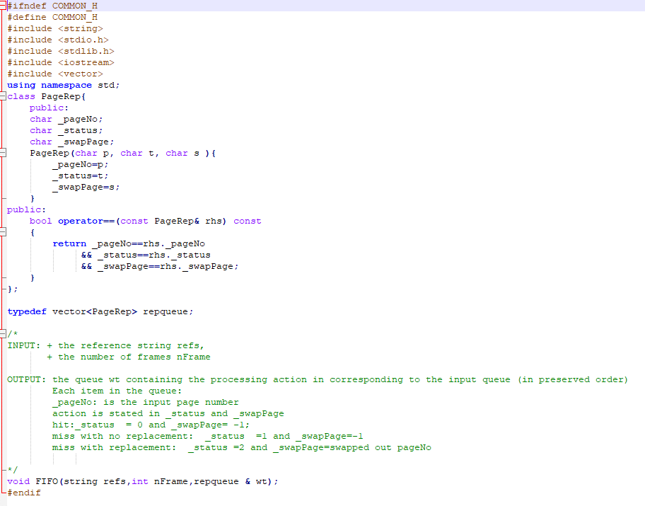

The procedure FIFO is what you have to program.

## /*

## INPUT: + the reference string refs,

## + the number of frames nFrame

## 

## OUTPUT: the queue wt containing the processing action in corresponding to the input queue (in preserved order)

## Each item in the queue:

## _pageNo: is the input page number

## action is stated in _status and _swapPage

## hit:_status = 0 and _swapPage= -1;

## miss with no replacement: _status =1 and _swapPage=-1

## miss with replacement: _status =2 and _swapPage=swapped out pageNo

## 

## */

## void FIFO(string refs,int nFrame,repqueue & wt);

## main.cpp

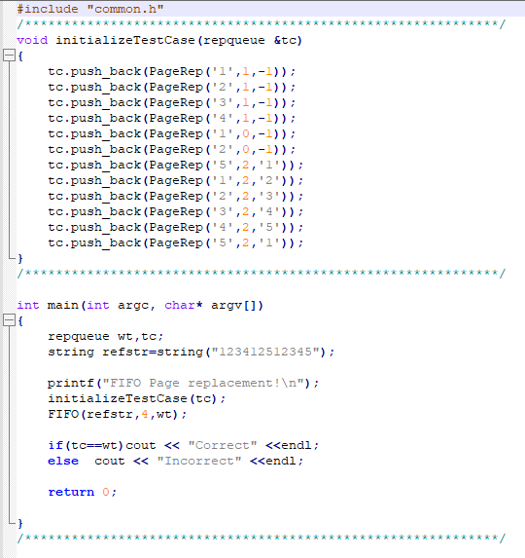

This contains the variable declaration and test case.

## Makefile

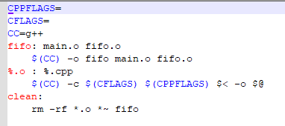

# Problem

Write the void FIFO(string refs,int nFrame,repqueue & wt); procedure in the fifo.cpp file